Creating the prototype of empathetic chatbot
Research Proposal
Student: Myint Myat Kyaw ID: 6610207
Course: CSC485 Instructor: Dr.Chutima

Table of Contents

Abstract

Chapter 1: Introduction
1.1 Introduction
1.2 Research Objectives
1.3 Research Question
1.4 Research Framework

Chapter 2: Related Literature Review and Conceptual Background
2.1 Empathy and Reflective Communication in Emotional Support
2.2 Emotional Self-Awareness and Emotion Regulation
2.3 Affect Labeling and Emotional Reflection
2.4 Emotional Insight Feature Explanation
2.5 Psychological Needs and Supportive Interaction
2.6 Technology Choices for an Empathetic Chatbot System
2.7 Related Research

Chapter 3: Research Methodology
3.1 System Framework
3.2 System Design
3.2.1 Use Case Diagram
3.2.2 Use Case Descriptions
3.2.3 System Workflow
3.2.4 User Interface Design
3.3 System Implementation
3.3.1 Development Environment
3.3.2 Libraries and Frameworks
3.3.3 API Usage
3.3.4 Dataset and Model Selection
3.4 Evaluation Design
3.5 Ethical Considerations
3.6 Limitations

Chapter 4: Results and Discussion
4.1 Overview of Evaluation
4.2 Qualitative Interaction Analysis
4.3 User Feedback and Survey Results
4.4 Discussion of Results
4.5 Limitations
4.6 Chapter Summary

Chapter 5: Conclusion
5.1 Conclusion
5.2 Contributions of the Study
5.3 Limitations
5.4 Future Work

References

Research Topic
AI for Mental Health: Toward More Empathetic and Context-Aware Systems

Abstract
AI chatbots are increasingly used for mental health–related support because many users feel more comfortable expressing emotions to an AI than to other people. Although existing chatbots can generate empathetic responses, users often lack awareness of their own emotional state during conversations. This limits emotional reflection and self-regulation.
This study proposes an empathetic mental health chatbot prototype that enhances user self-awareness through emotional transparency. The system analyzes user messages to identify emotions and psychological needs and presents this information through an Emotional Insight panel while generating supportive, non-clinical responses.
The prototype was implemented as a web-based system using Python, FastAPI, and a large language model API, with built-in safety mechanisms to prevent diagnosis and encourage professional support during high-risk situations. A small-scale qualitative evaluation suggests that displaying emotional insights helps users better understand their emotions and increases perceived empathy and trust in the system.
This study demonstrates that integrating emotional self-awareness features can improve AI-assisted mental health support while maintaining ethical boundaries and avoiding clinical claims.

Chapter 1

1.1 Introduction
In recent years, Artificial Intelligence (AI) chatbots have become increasingly common in daily life. Beyond providing information or completing tasks, many chatbots are now used for emotional and mental health–related support. Research suggests that users may feel more comfortable opening up to chatbots because they experience reduced fear of judgment and greater anonymity compared to speaking with other people (Fitzpatrick et al., 2017). This makes conversational AI a promising tool for non-clinical emotional support.
While modern chatbots are able to generate polite and empathetic responses, an important limitation remains. Users are often unaware of their own emotional state while interacting with these systems. Individuals may express sadness, stress, or frustration without clearly recognizing or reflecting on what they are feeling at that moment. Psychological research has shown that emotional awareness is a key component of emotion regulation, and limited awareness may reduce a person’s ability to manage emotional responses effectively (Gross, 2015). As a result, emotional conversations may continue without reflection or self-control, increasing the risk of emotional escalation.
Empathetic chatbots aim to address emotional distress by acknowledging user feelings, reflecting emotional content, and responding in a supportive and non-judgmental manner. The use of reflective communication has long been recognized as a fundamental method in psychological counseling and emotional support, as it helps individuals feel understood and validated (Rogers, 1957). Many existing AI chatbots attempt to apply empathetic language; however, empathy is often delivered only through responses, without helping users understand their own emotional state.
During early experimentation with existing AI chatbots, it was observed that although the responses were supportive, users were not provided with explicit feedback about their emotions. This represents a significant gap, as research indicates that identifying and labeling emotions—often referred to as affect labeling—can reduce emotional distress and support emotional regulation processes (Lieberman et al., 2007). Without such feedback, users may remain unaware of their emotional patterns during interaction.
To address this gap, this project proposes an empathetic mental health chatbot prototype that includes an Emotional Insight feature. This feature presents users with a simple interpretation of their emotional state during the conversation, including detected emotions and related psychological needs. The concept is similar to looking at oneself in a mirror while speaking. By seeing their emotions displayed in real time, users may develop greater self-awareness, better understand their feelings, and regulate their responses more consciously (Gross, 2015; Lieberman et al., 2007). This approach emphasizes emotional reflection and self-awareness rather than diagnosis or treatment, and is designed to support users ethically within a non-clinical context.

1.2 Research Objectives
The objectives of this research are as follows:
1) To design an empathetic chatbot prototype.
2) To develop an empathetic chatbot prototype that integrates tone and emotion detection with empathy-guided response generation.
3) To evaluate the empathetic chatbot prototype in terms of users’ self-awareness.

1.3 Research Question
How can AI systems be developed to be more empathetic and emotionally intelligent in mental health care?
1.4 Research Framework
This study adopts a system-oriented research framework that focuses on the design, implementation, and evaluation of an empathetic mental health chatbot. The detailed system framework and component interactions are presented and explained in Chapter 3.

Chapter 2

Related Literature Review and Conceptual Background

This chapter reviews relevant literature and foundational concepts related to empathetic communication and AI-based emotional support. The goal is to provide a clear theoretical background for readers who may not have a psychology or computer science background. Rather than focusing on implementation details, this chapter summarizes established theories and prior research that explain how empathy, emotional awareness, and supportive conversational strategies can influence a person’s emotional experience.
The chapter first discusses empathy and reflective communication, which are commonly used in counseling and supportive conversations. It then reviews emotional self-awareness and emotion regulation, highlighting why recognizing emotions is important for managing distress. Next, the chapter introduces affect labeling, a concept supported in psychological research that suggests naming emotions can reduce emotional intensity. The chapter also discusses the idea of emotional transparency in digital support tools, including potential benefits and risks. After that, it explains psychological needs in emotional conversations and how supportive responses can be aligned with those needs. Finally, the chapter reviews ethical concerns and related research to position this study within existing work on mental-health chatbots and AI support systems.

Key Concepts Used in This Chapter
To support readers from non-psychology and non-computer-science backgrounds, this section briefly defines several terms that are commonly used in research on emotional support and mental-health chatbots.
- Empathy refers to understanding another person’s emotional experience and communicating that understanding in a supportive way (Rogers, 1957).
- Reflective listening is a technique where the listener restates the speaker’s feelings to show understanding and acceptance (Rogers, 1957).
- Emotion regulation describes how people influence which emotions they have, when they have them, and how they experience or express them (Gross, 2015).
- Affect labeling means putting feelings into words (e.g., “I feel anxious”), which may reduce emotional distress and support calmer processing (Lieberman et al., 2007).
- Emotional awareness refers to recognizing and describing one’s own emotional state, which is closely related to self-control and mental well-being (Gross, 2015).
- Transparency in AI systems generally refers to how clearly a system communicates what it is doing and why, which can affect trust and safe use (Lee et al., 2021).

2.1 Empathy and Reflective Communication in Emotional Support
Empathy is one of the most important parts of emotional support. When someone is stressed or sad, they often do not need “perfect advice” first. Many times, they need to feel understood. Empathy helps people feel less alone, and it can make conversations safer and calmer.
Rogers (1957) is a key source in psychology for understanding supportive communication. Rogers explained that people are more likely to grow and cope better when the conversation feels emotionally safe. He described “necessary and sufficient conditions” for positive change in a helping relationship. Key ideas include:
- Empathy: the helper understands the person’s feelings and experience
- Unconditional positive regard: the helper accepts the person without judging or blaming
- Genuineness: the helper is real and sincere, not pretending
Rogers also emphasized reflective listening. Reflective listening means responding by reflecting feelings back to the person. It is not copying the same sentence. It is showing you understood what the emotion is. For example:
- “That sounds really exhausting.”
- “It makes sense you feel hurt after that.”
- “It seems like you’ve been carrying this alone for a long time.”
Reflective communication is powerful because it does two things at the same time:
- it shows the person they are heard, and
- it helps the person understand their own emotions more clearly (Rogers, 1957).
Fitzpatrick et al. (2017) shows that these supportive ideas can also work in chatbot form. Their study evaluated a chatbot that delivered CBT-style support using a randomized controlled trial. A randomized controlled trial is strong because it compares groups in a structured way, not just opinions. Their results suggested users reported improvement in depressive symptoms, and users were willing to talk to the chatbot because it felt private and less judgmental than talking to people (Fitzpatrick et al., 2017). This matters for chatbot research because it shows users may accept emotional support from AI when the communication style feels supportive.
At the same time, many chatbots mainly express empathy through the response text only. They might respond kindly, but they do not always help the user notice their own emotional state. That point connects to the next section about emotional self-awareness.

2.2 Emotional Self-Awareness and Emotion Regulation
Emotional self-awareness means noticing and understanding your own emotions. This includes being able to answer simple questions like:
- “What am I feeling right now?”
- “Is it mild or intense?”
- “What triggered it?”
Emotion regulation means managing emotions in a healthy way. It does not mean removing emotions. It means emotions do not fully control your actions. For example, someone can feel angry but still pause before texting something harmful. Someone can feel anxious but still calm down and think step by step.
Gross (2015) explains that emotion regulation works better when emotions are recognized early. If people do not notice what they are feeling, they are more likely to react automatically. That reaction can be impulsive (sudden anger, panic), or it can be slow and harmful (rumination, constant worry). Gross also describes that emotions can be managed in different ways, and people can choose different strategies depending on the situation. His work is often explained as a “process” because emotions usually develop step-by-step, not instantly.
A useful way to think about Gross (2015) is this:
- emotions start from a situation (something happens),
- then attention and thinking shape how we experience it,
- and then the body and behavior respond.
If a person notices the emotion earlier, they have more chances to regulate it. If they notice it late, the emotion might already feel too big and difficult to manage (Gross, 2015).
This is important for mental health–adjacent chatbots. If a chatbot can support self-awareness (help users notice what they are feeling), it may support emotion regulation. The chatbot does not need to “fix” the user. It can help the user pause, recognize what is happening emotionally, and decide what to do next in a calmer way.

2.3 Affect Labeling and Emotional Reflection
Affect labeling means naming emotions using words. For example:
- “I feel disappointed.”
- “I feel anxious.”
- “I feel overwhelmed.”
This seems small, but research shows it can reduce emotional intensity.
Lieberman et al. (2007) studied affect labeling using brain scans. In their study, participants viewed emotional stimuli and then used words to label the emotion. The findings showed that labeling emotions was linked to reduced activity in brain regions related to emotional distress, and increased activity in areas related to control and thinking (Lieberman et al., 2007). You do not need to understand brain anatomy to understand the main point. The key message is:
When people put feelings into words, the emotion often becomes easier to handle.
In real life, affect labeling can work like this:
- Before labeling: “I feel terrible. I don’t know why.”
- After labeling: “I feel anxious because I’m scared something will go wrong.”
The second one is still uncomfortable, but it is clearer. Clarity helps people choose better coping actions. It also helps people feel less confused and less overwhelmed.
However, Lieberman et al. (2007) does not mean labeling is always perfect. If the label is wrong, the person might feel misunderstood. So emotional labels should be used carefully. They should feel like helpful feedback, not like a strict judgment.

2.4 Emotional Feedback and Transparency in Support Systems
In emotional conversations, people often benefit when their feelings are reflected back to them. Rogers (1957) explained that reflective listening helps a person feel understood and can support self-exploration. When someone hears their feelings reflected, they may notice emotions more clearly and feel more accepted.
Research on emotion regulation also suggests that noticing emotions is an important first step before managing them. Gross (2015) explained that emotion regulation becomes more effective when emotions are recognized early. If a person cannot identify what they feel, it can be harder to choose a helpful coping strategy.
Affect labeling research gives another reason why emotional feedback can help. Lieberman et al. (2007) showed that naming emotions with words is linked to reduced emotional distress and increased cognitive control. This suggests that emotion words can support reflection and make emotions easier to handle.
In addition to these psychological ideas, review papers on AI in mental health often stress the importance of responsible design. Lee et al. (2021) discussed the need for value-aware AI in mental healthcare, including trust and safety. The Psychological Medicine (Cambridge) review also highlights concerns such as interpretability and safe deployment, which are connected to transparency. The BMC Psychiatry (2025) review notes that many studies have limited external validation, meaning systems may not work consistently for real users. Together, these works suggest that emotional-support AI systems should be careful about how they present emotional information and should avoid strong or medical claims.
Emotional feedback may help because it supports self-reflection. When users see emotions reflected or labeled, they may pause and better understand what they are feeling, which can support emotional self-awareness and regulation (Gross, 2015; Lieberman et al., 2007).
However, emotional feedback can also be risky if it is inaccurate or presented too confidently. An incorrect label may feel invalidating, and users may misunderstand the output as a diagnosis. Therefore, prior work emphasizes responsible design and clear limitations when AI is used in mental health–adjacent contexts (Lee et al., 2021; BMC Psychiatry, 2025).

2.5 Psychological Needs and Supportive Interaction
Emotional support is not only about recognizing emotions. It is also about understanding what a person needs in that moment. Here, “needs” means emotional support needs, not physical needs.
When a person feels something strongly, different support styles can help:
- Validation: “It makes sense you feel that way.”
- Reassurance: “You’re not alone. We can take this step by step.”
- Grounding: “Let’s slow down. What is one thing you can focus on right now?”
- Encouragement: “You’ve handled hard things before. What small step feels possible today?”
In supportive conversations, matching the support style to the user’s emotional state is important. For example, if someone is anxious, “problem solving” too early can make them feel unheard. If someone is sad, telling them to “be strong” can feel invalidating. Support often works better when it follows this order:
- understand the feeling
- validate it
- then move toward coping steps
This fits Rogers (1957) because acceptance and empathy help people feel emotionally safe. It also fits Gross (2015) because regulation becomes easier when emotions are recognized clearly and handled in a suitable way. It also fits Lieberman et al. (2007) because naming emotions supports calmer processing.
Needs-based support is also helpful for non-clinical design. Instead of diagnosing, the system focuses on supportive communication behaviors that are commonly safe and helpful.

2.6 AI in Mental Health: Benefits, Risks, and Ethical Limits
AI has been used in mental health research for tasks like monitoring, prediction, and intervention support. But mental health is sensitive, so researchers often warn that AI systems can cause harm if they are not designed carefully.
Lee et al. (2021) reviewed AI in mental healthcare and explained that many AI systems look promising in research but face problems in real-world use. Their review highlights issues like trust, bias, and the gap between research success and safe clinical deployment. They also argue mental health AI should be guided by human values (sometimes described as “artificial wisdom”), not only technical performance (Lee et al., 2021). This is important because a system might be “accurate” in some tests, but still harmful if it is unfair, unsafe, or used in the wrong way.
The BMC Psychiatry systematic review (2025) also reports that AI mental health studies are very mixed in methods. Many studies have limited external validation, meaning results may not hold when the model is used with different real users in different settings. This is a serious issue in mental health because people express emotions differently across cultures, age groups, and communication styles (BMC Psychiatry, 2025).
The Psychological Medicine (Cambridge) review also highlights common concerns such as privacy, interpretability, and deployment barriers. Privacy matters because mental health conversations can include personal and sensitive information. Interpretability matters because users and researchers should understand why the system outputs something, especially when the output might influence a user’s feelings or decisions.
Because of these risks, mental health–adjacent chatbots should have clear ethical limits, such as:
- not diagnosing mental disorders
- not acting like a therapist
- not giving medical treatment instructions
- encouraging professional support when risk is high
- being careful with strong claims
These boundaries are consistent with the concerns raised in the review literature (Lee et al., 2021; BMC Psychiatry, 2025; Psychological Medicine review).

2.7 Related Research
Table 1 summarizes sources and their relevance to the research question.
Paper | Scope of work | Objective of the work | Method Used | Finding | Relation to our research question
Reuters (2024): AI fails to detect depression in Black Americans | News report on peer‑reviewed study; language‑based depression screening | Assess bias across racial groups | Off‑the‑shelf models on social‑media language vs. validated questionnaire | Much lower predictive validity for Black participants | Motivates fairness checks and subgroup evaluation
Lee et al. (2021) – PMC: AI in Mental Healthcare; Artificial Wisdom | Review of clinical AI applications, barriers, facilitators | Map opportunities and risks; argue values‑aware design | Literature synthesis | Gap between research promise and clinical use; need empathy/fairness | Inspires empathy‑centered requirements and ethics framing
BMC Psychiatry (2025): Systematic review of AI in mental health | Survey of applications across diagnosis, monitoring, prediction | Summarize performance and gaps | Systematic review | Heterogeneous methods; limited external validation | Supports need for standardized evaluation and diverse data
Psychological Medicine (Cambridge): Review of diagnosis/monitoring/intervention | Broad review of AI in MH care | Identify technical and ethical limitations | Literature synthesis | Privacy, interpretability, deployment barriers | Guides interpretability and safety requirements
arXiv (2024): Emotional modeling for dialogue systems | Techniques for affect representation and generation | Improve affect‑aware responses | Method proposals; experiments | Modeling affect can enhance response quality | Grounds the empathy module of the prototype
arXiv (2025): Conversational empathy and fairness | Assessment and improvement of empathy with fairness tracking | Jointly optimize empathy and fairness | Benchmarks and analyses | Empathy metrics can be combined with subgroup audits | Directly informs evaluation plan
Fitzpatrick et al. (2017): Delivering Cognitive Behavioral Therapy Using Chatbots | Empirical study evaluating a chatbot designed to deliver mental-health support to users. | To examine whether chatbot-based emotional support can reduce symptoms of depression and anxiety. | A randomized controlled trial comparing user outcomes between chatbot interaction and control conditions. | Users reported reduced depressive symptoms and felt comfortable sharing emotions due to anonymity and reduced judgment. | Supports the idea that AI systems can provide emotionally supportive interactions and that users may feel safe expressing emotions to chatbots.
Rogers (1957): The Necessary and Sufficient Conditions of Therapeutic Personality Change | Foundational psychological theory on empathy and counseling communication. | To define core conditions required for effective emotional support and personal growth. | Theoretical framework based on clinical observation and counseling practice. | Empathy, reflective listening, and unconditional positive regard are essential for emotional safety and self-exploration. | Provides the theoretical foundation for empathetic response design and reflective communication used in the chatbot.
Gross (2015): Emotion Regulation | Psychological review on emotional awareness and regulation processes. | To explain how individuals recognize, experience, and regulate emotions. | Review and synthesis of emotion-regulation research. | Emotional awareness is a critical first step for effective emotion regulation and mental well-being. | Justifies the inclusion of the Emotional Insight feature to help users recognize and reflect on their emotional state.
Lieberman et al. (2007): Putting Feelings Into Words | Neuroscientific study on affect labeling and emotional processing. | To investigate how labeling emotions affects emotional intensity and brain activity. | fMRI experiments measuring neural activity during emotion labeling tasks. | Labeling emotions reduces emotional distress and increases cognitive control. | Directly supports the design of the Emotional Insight feature, which presents emotion labels to encourage reflection and regulation.
It was found across sources that models may underperform for certain communities and that emotionally neutral outputs can be perceived as unsupportive. Overall, the reviewed sources suggest that AI chatbots can provide supportive interactions, but important challenges remain, including bias across user groups, limited external validation, privacy concerns, and safe deployment in real-world settings. These concerns highlight the need for emotional-support systems that communicate carefully, avoid clinical claims, and emphasize safety and fairness.

Chapter 3: Research Methodology

3.1 System Framework
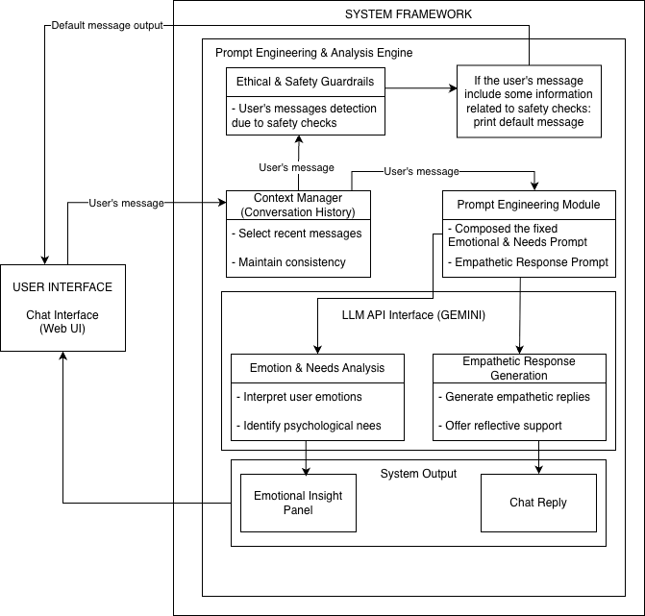
Figure 3.1 System Framework

Figure 3.1 illustrates how the system processes a user’s message and produces two outputs: (1) an empathetic chat reply and (2) structured Emotional Insight data. The system is designed for non-clinical emotional support, so it does not diagnose medical conditions and it includes safety guardrails to handle risky messages. The processing steps are organized into components to make the system easier to control and easier to explain.
Privacy note: The prototype processes the user’s message and recent conversation turns to generate outputs. API credentials are stored server-side and are not exposed to the web client. If any chat logs are stored for testing, they should be anonymized and protected, and users should be informed about data handling

Technical Terms
- API endpoint: a server function the web interface calls to process a message and return results.
- Prompt: the instruction text sent to the AI model to control output style and structure.
- JSON: a structured text format used to return fixed fields (e.g., emotion, intensity, needs).
- Regex: a pattern-matching method used to detect specific phrases (e.g., self-harm wording).
- Parsing: converting the model’s text output into structured data the program can use safely.

3.1.1 System Interface Between UI and Backend (API Endpoint)
The main processing happens in the server-side API endpoint shown below. This function receives the user message (and recent conversation history) and runs the pipeline steps in order.
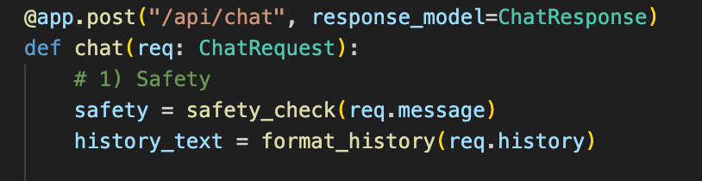
Figure 3.2 Main FastAPI Endpoint for Processing User Messages
In simple terms, this function acts as the main controller of the system pipeline. Every time the user sends a message, the web interface sends a request to this endpoint first. The endpoint then (1) checks whether the message contains risky content, (2) prepares conversation history for context, (3) requests emotion-and-needs analysis from the AI model, (4) requests an empathetic reply from the AI model, and (5) returns both outputs to the interface. This endpoint is not a reasoning component; it is the interface that receives requests from the chat interface and triggers the framework components below.

3.1.2 Overall Workflow
To summarize the framework in Figure 3.1, the system follows these steps:
(1) the user sends a message through the chat interface,
(2) the interface sends the message and recent history to the backend interface,
(3) safety screening runs first to detect crisis/self-harm wording,
(4) if safe, conversation history is formatted for context,
(5) the system requests emotion-and-needs analysis in structured JSON,
(6) the system generates an empathetic reply and returns both outputs (reply + Emotional insight data) to the interface.

3.1.3 User and Chat interface
The user starts the interaction by entering text messages that describe thoughts, feelings, or concerns. The chatbot is designed for non-clinical emotional support and does not require users to provide personal, medical, or diagnostic information.
The chat interface is the main point of interaction between the user and the chatbot system. It allows users to type messages, read chatbot replies, and view the Emotional Insight panel. The interface is implemented as a web-based application that can be accessed through a browser.
User messages, along with recent conversation history, are sent from the interface to the backend system for processing. The interface itself does not analyze emotions and is only responsible for displaying system results.

3.1.4 Context Manager (Conversation History)
The context manager keeps recent conversation messages so the system can respond in a way that matches what the user and assistant already talked about. Instead of treating every message like a new conversation, the system uses the last few turns to stay consistent.
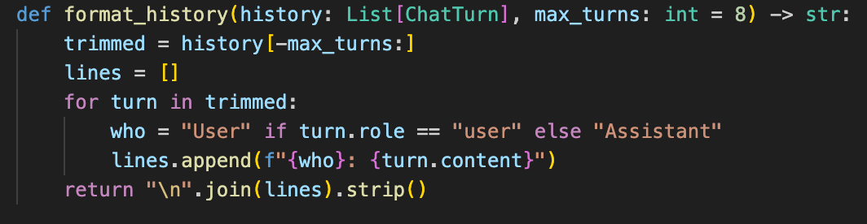
Figure 3.3 Conversation History Trimming and Formatting Function
This code does three important things:
- Limits the amount of history
The line trimmed = history[-max_turns:] keeps only the last few turns. This is done for two reasons:
  - long conversations can become too large and slow
  - the AI model can get confused if too much text is included
- Formats the history into a readable block
The system converts the history into a simple format like:
“User: …” and “Assistant: …”
This makes it easier for the AI model to understand what happened earlier.
- Prepares the history for the prompts
The final output is one text block. That text block is inserted into the prompts so the AI model can respond with context.
Then, the formatted history is used inside the main pipeline like this:

Figure 3.4 Integration of Formatted Conversation History into Prompt

3.1.5 Ethical and Safety Guardrails
Before the system does emotion analysis or generates an empathetic reply, it checks if the user message contains strong self-harm or crisis wording. If risk is detected, the system stops the normal flow and returns a safety-focused message.
The safety guardrail starts with a list of risky patterns:
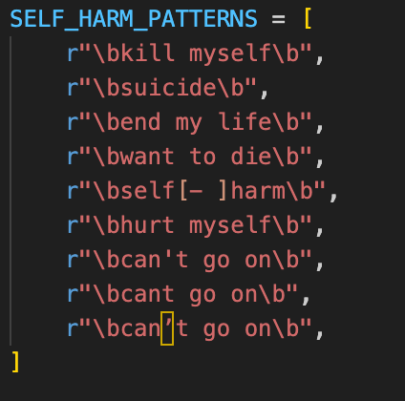
Figure 3.5 Self-Harm Risk Pattern List for Safety Screening
This is basically a “warning list” of phrases. The system uses this list to quickly screen messages for crisis language.
The checking logic is done in this function:
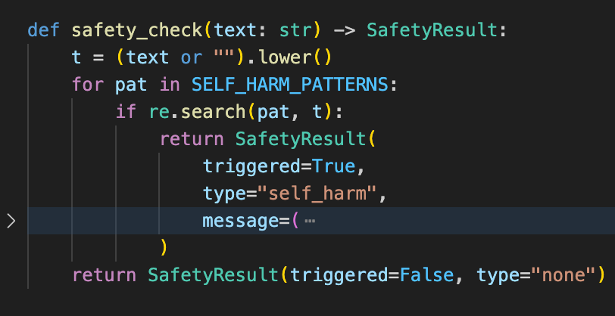
Figure 3.6 Self-Harm Detection Function Using Regular Expression
Here is what the code is doing in plain language:
- t = (text or "").lower()
The system converts the message to lowercase so it can match words more reliably (for example “Suicide” and “suicide” should be treated the same).
- for pat in SELF_HARM_PATTERNS:
The system checks the message against each risky phrase one by one.
- if re.search(pat, t):
If a risky phrase is found, the safety check is triggered.
If the safety check is triggered, the system returns early in the main pipeline:
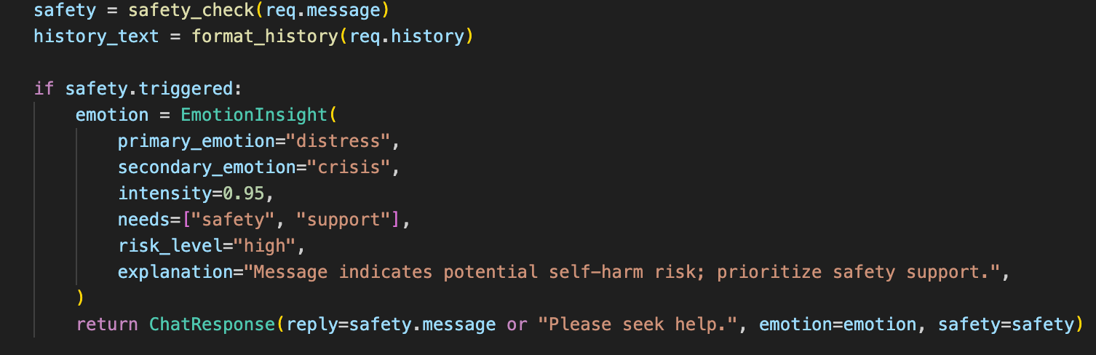
Figure 3.7 Early Return Safety Response in Main Pipeline
This is important because it shows the system does not continue normal AI generation when the message looks dangerous. It immediately switches to a safer response. The system also assigns a high-risk classification within the Emotional Insight data so the UI can reflect the situation responsibly.

3.1.6 Prompt Engineering Module
The prompt engineering module controls how the large language model generates outputs within the system. Rather than training or fine-tuning a custom emotion classification model, this prototype relies on carefully designed prompts to guide the model’s behavior. This approach allows structured emotional interpretation and empathetic response generation without modifying the underlying model parameters.
The system uses prompt engineering for two distinct tasks:
- Emotion and needs Prompt (structured JSON output)
- Empathetic reply generation (natural language output)

Prompt 1: Emotion and Needs Prompt (structured JSON)
The system requires the AI model to return emotional analysis results in a consistent, machine-readable format. To achieve this, a strict JSON schema is embedded directly into the prompt.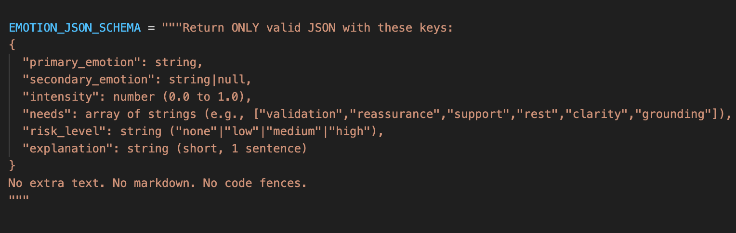
Figure 3.8 Emotion and Needs JSON Schema Definition
This schema defines the exact structure that the language model must follow when returning emotional analysis results. By specifying required keys and data types, the system reduces output variability and ensures that the Emotional Insight panel receives predictable, structured information.
The schema contains the following fields:
primary_emotion (string)
This field represents the dominant emotion inferred from the user’s most recent message. It captures the strongest emotional signal expressed (e.g., sadness, anxiety, frustration). The primary_emotion field is required to ensure that the system always produces a clear emotional interpretation.
secondary_emotion (string | null)
This optional field captures an additional emotion when the user expresses layered or mixed emotional states. If no secondary emotion is detected, the value is set to null. Allowing a null value prevents artificial overclassification and supports flexible emotional representation
intensity (number between 0.0 and 1.0)
This numerical value represents how strongly the emotion is expressed. A normalized range between 0 and 1 allows consistent comparison across different user messages and supports potential frontend visualization (e.g., intensity bars or scaled indicators).
needs (array of strings)
This field contains inferred psychological support needs associated with the detected emotional state. Examples include validation, reassurance, grounding, support, rest, and clarity. Structuring needs as an array enables prioritized support strategies in the empathetic reply generation stage.
risk_level (string: “low” | “medium” | “high”)
This field indicates whether the message contains signs of elevated emotional distress. The risk_level variable does not represent a medical diagnosis. Instead, it functions as a safety-aware classification that enables conditional response logic, particularly for activating guardrails or crisis-sensitive messaging.
By enforcing this structured schema, the system minimizes ambiguous outputs and prevents the model from generating long explanatory paragraphs during the emotional analysis stage. Instead, the model is constrained to produce concise, machine-readable emotional insight data. This design improves reliability, interpretability, and safe integration into downstream components such as validation modules and the empathetic reply generation pipeline.

Emotion Prompt Construction
After defining the schema, the system constructs the full emotion-analysis prompt by embedding the schema instructions, conversation context, and safety boundaries.
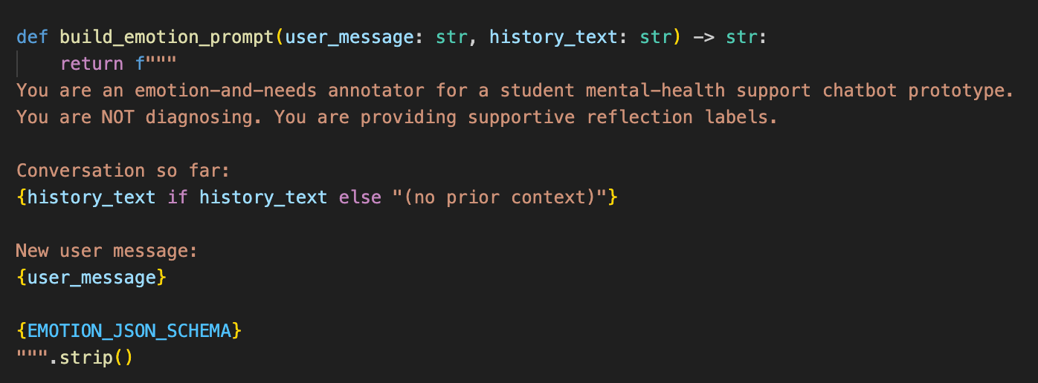
Figure 3.9 Emotion and Needs Prompt Construction
The emotion prompt includes three core design principles:
Non-clinical boundary
The instruction “You are Not diagnosing” is explicitly included to prevent the model from producing medical claims, diagnostic language, or therapeutic authority. This constraint reinforces the system’s non-clinical positioning.
Conversation context integration
The prompt includes formatted conversation history (e.g., “Conversation so far”) to ensure that emotional interpretation reflects ongoing dialogue rather than isolated messages.
Strict output formatting instruction
The schema is attached directly to the prompt, and the instruction “Return ONLY valid JSON” is provided to restrict output structure. This reduces the likelihood of extraneous text or markdown formatting.

For Input–Output Flow and Limitations
Within the system pipeline, the input consists of the user’s message and recent conversation history. These inputs are processed by the prompt engineering module, which produces two distinct prompts: one for structured emotional analysis and one for empathetic reply generation.
Because large language models are probabilistic systems, prompt-based outputs may vary slightly across interactions. To mitigate variability, the system enforces strict JSON schema constraints and incorporates fallback handling mechanisms. If structured parsing fails, the system substitutes a predefined safe fallback structure to maintain stability and prevent application errors.
This combination of prompt constraint, schema validation, and fallback handling ensures that emotional insight generation remains consistent, interpretable, and aligned with ethical boundaries.

3.1.7 LLM API Interface (Gemini)
The LLM API interface is the part that sends prompts to the external AI model and receives outputs. The system creates a Gemini client like this:
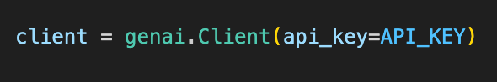
Figure 3.10 Gemini API Client Initialization
Then the system uses one helper function to call the model:
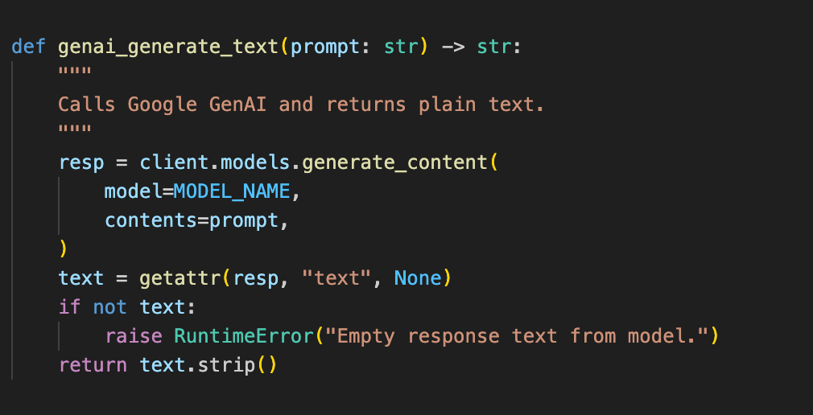
Figure 3.11 Helper Function for Generating Text via LLM API
This function is used for both tasks (emotion analysis and reply generation). This makes the system easier to maintain because the “model calling” logic is in one place. If the model returns an empty output, the function throws an error so the system can handle it instead of silently failing.
Limitation: Because the model is external, responses may occasionally be empty or inconsistent; keeping all model calls in one helper function makes error handling and maintenance easier.

3.1.8 Emotion and Needs Analysis
After safety passes, the system runs emotion and needs analysis first. The steps are:
Figure 3.12 JSON Code Fence Cleaning Before Parsing
Sometimes models wrap JSON inside code fences like json … , so the system removes that:
Figure 3.13 Emotion JSON Parsing into Python Object
Then it parses the JSON into a Python object:
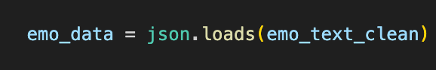
Figure 3.14 Fallback Emotion Structure for Parsing Errors
If parsing fails, the system uses a fallback result so it can still continue safely:
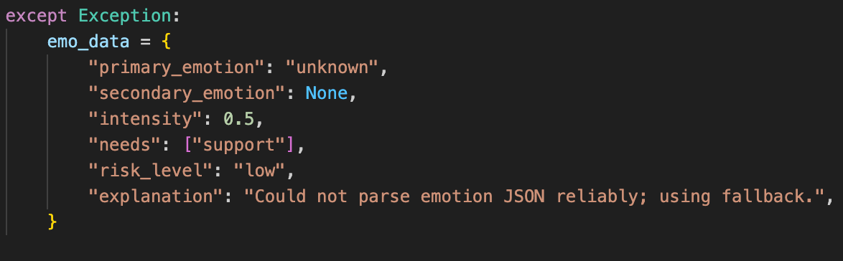
Figure 3.15 Emotion Data Validation Using Pydantic Model
This fallback is necessary because LLM outputs are not guaranteed to be perfectly structured every time. If JSON parsing fails, the fallback prevents the system from crashing and ensures the Emotional Insight panel still receives stable fields (emotion, intensity, needs, risk). This improves reliability and keeps the user interface consistent.
Finally, the system validates the structure using a defined model:
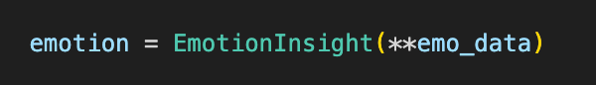
Figure 3.16 Empathetic Reply Prompt Construction
This validation step is important because the Emotional insight panel depends on stable fields. If the system always returns the same keys (emotion, intensity, needs, risk), the UI can display it clearly for non-technical users.

3.1.9 Emotional Insight Panel
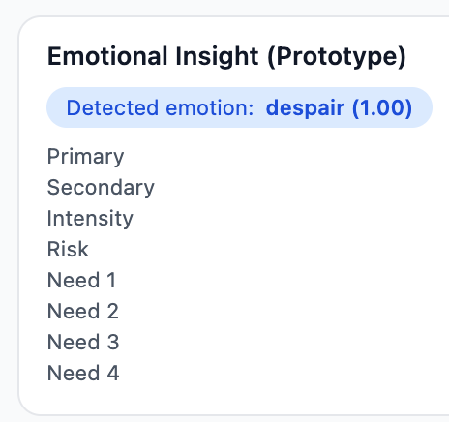
Figure 3.17 Emotional Insight Panel and their example of data
The Emotional Insight panel represents the user-facing component of the structured emotional analysis described in Section 3.1.6. While the backend module generates structured emotional insight data, this section explains how that information is presented to users and how it supports emotional self-awareness within a non-clinical context.
The Emotional Insight panel is displayed alongside the empathetic reply. Its purpose is to make the system’s interpretation of the user’s emotional state transparent and interpretable. Rather than functioning as a diagnostic tool, the panel serves as a reflective aid, encouraging users to observe and consider their emotional experiences more consciously.
The panel presents five elements derived from the emotional insight data:
Primary Emotion
The Primary Emotion represents the dominant emotional tone inferred from the user’s most recent message. Displaying a clear emotional label allows users to pause and reflect on whether the identified emotion aligns with their internal experience. Even when the interpretation is not perfectly accurate, the presence of a labeled emotion can stimulate clarification and self-exploration.
This mechanism is aligned with research on affect labeling, which suggests that naming emotions can reduce emotional intensity and support cognitive regulation (Lieberman et al., 2007).
Secondary Emotion (Optional)
Emotional experiences are often complex and layered. When applicable, the system displays a Secondary Emotion to represent additional emotional nuance. This prevents oversimplification of the user’s emotional state and acknowledges that individuals may experience multiple emotions simultaneously (e.g., sadness combined with frustration).
By allowing emotional plurality, the panel supports a more realistic representation of human affective experience.
Emotional Intensity
Emotion intensity is displayed as a value between 0 and 1, indicating the relative strength of the detected emotion. This numerical representation communicates gradation rather than binary classification.
Presenting intensity encourages users to distinguish between mild discomfort and heightened distress. Such differentiation may support emotional awareness and help users regulate responses more effectively (Gross, 2015).
The intensity value can also be visually represented in the interface (e.g., scaling indicators or bars), enhancing intuitive comprehension without requiring technical understanding.
Psychological Needs
The panel lists inferred psychological support needs associated with the detected emotional state. These needs do not function as prescriptions or treatment recommendations. Instead, they represent supportive directions that may be helpful in the current emotional context (e.g., validation, reassurance, grounding, clarity).
Displaying needs explicitly shifts the conversation from simply identifying emotion to considering what type of support may be appropriate. This encourages reflective thinking about emotional coping strategies rather than passive reception of advice.
Risk Level
The risk level indicates whether the user’s message contains signs of elevated emotional distress. When a high-risk level is detected, the system prioritizes safety-oriented language in the empathetic reply and may encourage professional support.
Importantly, the risk level is not presented as a clinical assessment or diagnostic judgment. It functions solely as a precautionary classification that supports responsible interaction and ethical boundaries.
Role in Emotional Transparency
Unlike conventional chatbots that provide empathetic responses without revealing internal interpretation processes, this system deliberately exposes structured emotional insight data to the user. This transparency supports meta-awareness — the ability to observe one’s own emotional state from a reflective perspective.
By combining empathetic dialogue with visible emotional interpretation, the system encourages users to engage in both emotional expression and emotional reflection. This dual-layer design strengthens user trust, supports responsible AI interaction, and aligns with the system’s non-clinical and ethically constrained framework.

3.1.10 Empathetic Response Generation
After Emotion insight data is prepared, the system generates the actual chat reply using a second prompt. The prompt tells the model to respond in a supportive and structured way (validate → reflect → ask → suggest).
Figure 3.18 Empathetic Response Generation Using Emotion-Informed Prompt

Inside the reply prompt, the system inserts the Emotional Insight data so the reply can align with the detected emotional state.
Figure 3.19 Serialization of Emotion Data into JSON Format for Prompt Integration
This helps the model avoid generic replies and instead respond in a way that fits the detected emotion and needs.

3.1.11 System Output
The final system output includes two parts: a chatbot reply and the Emotional Insight panel. These outputs are sent back to the chat interface and shown to the user at the same time.
The chatbot reply provides emotional support through conversation, while the Emotional Insight panel shows a simple explanation of the user’s emotional state. Showing both together helps users better understand their emotions while receiving support.

3.2 System Design

3.2.1 Use Case Diagram

Figure 3.20 presents the use case diagram illustrating the interaction between the primary actor (User) and the Empathetic Mental Health Chatbot System. The diagram focuses on user-facing functionalities implemented in the prototype.
The User can perform the following actions:
- Send messages to the chatbot
- View empathetic responses generated by the system
- View the Emotional Insight panel
- Receive safety suggestions when risk is detected
- View conversation history
This diagram reflects the operational scope of the implemented prototype and excludes administrative or development-level functions, as the system is designed for direct user interaction only.
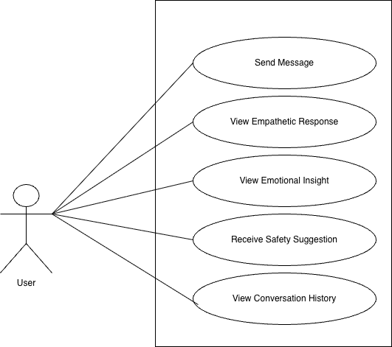
Figure 3.20 use case diagram

3.2.2 Use Case Descriptions
This section describes the key user interactions within the chatbot system.

Use Case: Send Message
Actor: User
Precondition: The user is on the chat interface.
Main Flow:
1. The user types a message into the chat input field.
2. The system receives the message and forwards it to the backend for processing.
Postcondition: The message enters the system pipeline for safety screening and emotional analysis.

Use Case: View Empathetic Response
Actor: User
Main Flow:
1. The system performs safety screening and emotion analysis.
2. The system generates an empathetic response based on detected emotional state and needs.
3. The response is displayed in the chat interface.
Postcondition: The user reads the empathetic reply.

Use Case: View Emotional Insight
Actor: User
Main Flow:
- The system generates structured Emotional Insight data.
- The Emotional Insight panel is displayed alongside the chatbot reply.
Postcondition: The user observes the interpreted emotional state and psychological needs.

Use Case: Receive Safety Suggestion
Actor: User
Precondition: Risk-related content is detected.
Main Flow:
- The system detects high-risk or crisis-related language.
- A safety-focused response is generated.
Postcondition: The user receives guidance encouraging professional support.

Use Case: View Conversation History
Actor: User
Main Flow:
- The system stores recent conversation turns.
- The conversation history is displayed in the chat interface.
Postcondition: The user can review previous messages.

3.2.3 System workflow of the empathetic mental health chatbot
Figure 3.21 illustrates the overall workflow of the proposed empathetic mental health chatbot system.
The process begins when the user submits a text message through the chat interface. The message is sent to the backend system, where a safety screening mechanism first checks for crisis-related or self-harm content. If high-risk content is detected, the normal processing pipeline is interrupted, and a safety-focused response encouraging professional support is generated.
If no immediate risk is detected, the system proceeds with emotion and needs analysis. The large language model is prompted to return structured Emotional Insight data, including primary emotion, secondary emotion (if applicable), emotional intensity, psychological needs, and risk level. The returned data is validated to ensure structural consistency.
Based on the validated Emotional Insight data, the system then generates an empathetic response tailored to the detected emotional state and support needs. Finally, both the empathetic response and the Emotional Insight panel are displayed to the user through the chat interface.
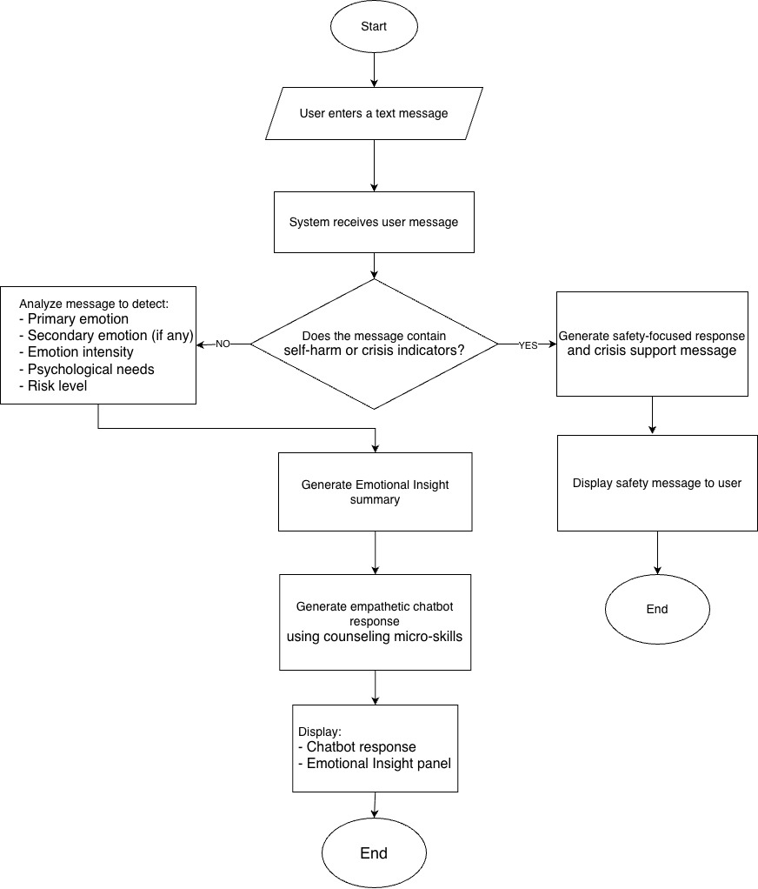
Figure 3.21 System Workflow of the Empathetic Mental Health Chatbot

3.2.4 User Interface (UI) Screenshot
The following figure presents the prototype interface of the empathetic mental-health support chatbot.
The UI provides a simple chat box that allows users to type messages and view responses generated by the system.
Figure 3.5 Website UI Prototype
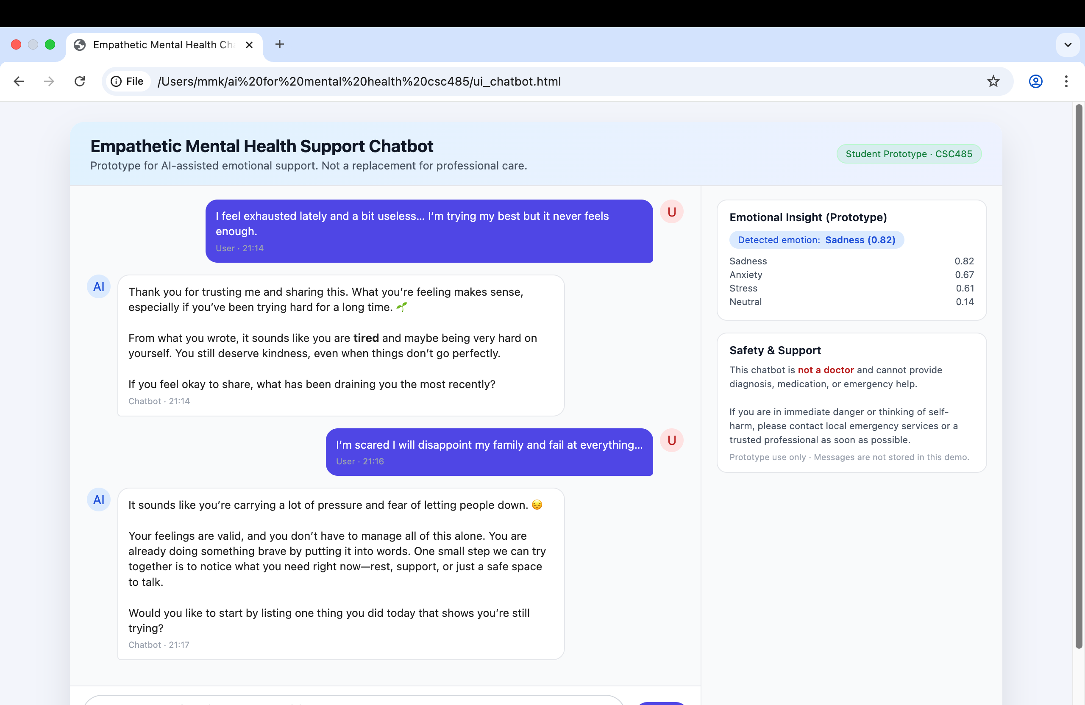

3.3 System Implementation

3.3.1 Development Environment
- Programming Language: Python
- Backend Framework: FastAPI
- Frontend Technologies: HTML, CSS, JavaScript
- Development Tool: Visual Studio Code (VS Code)
- Operating System: Cross-platform (Windows / macOS)

3.3.2 Libraries and Frameworks
The following Python libraries were used in the development of the prototype:
- fastapi – Backend API framework
- uvicorn – ASGI server for running the application
- python-dotenv – Environment variable management
- pydantic – Data validation and schema definition
- google-generativeai – API client for large language model interaction
Frontend assets include:
- Custom CSS for layout and accessibility
- JavaScript for chat interaction, history management, and emotional insight updates

3.3.3 API Usage
The system uses a large language model API to perform two main tasks:
- Emotion and Needs Interpretation
The model analyzes user input and returns structured emotional information, including primary emotion, intensity, and psychological needs.
- Empathetic Response Generation
The model generates supportive and empathetic responses based on predefined counseling micro-skills and safety rules.
All API usage is controlled through prompts that explicitly prevent diagnosis, medical advice, or unsafe content.

3.3.4 Dataset and Model Selection
This study does not train or fine-tune a custom emotion classification model. Instead, it relies on a pre-trained large language model that has been trained on diverse, publicly available text data.
The system uses prompt-based emotion interpretation to infer emotions and psychological needs from user messages. This approach avoids the need for collecting or training on sensitive mental health datasets, which aligns with ethical considerations for non-clinical research.
Public emotion datasets such as GoEmotions are referenced in this study to inform the conceptual design of emotion categories and emotional structure, rather than for direct model training or implementation.

3.4 Evaluation Design
To evaluate the proposed empathetic chatbot prototype, a user-based evaluation was conducted using a structured questionnaire implemented through Google Forms. The questionnaire was designed to assess user perceptions of empathy, emotional understanding, clarity of responses, ethical safety, and trust in the system. A five-point Likert scale ranging from 1 (Strongly Disagree) to 5 (Strongly Agree) was used to capture user feedback.
The evaluation questions were grouped into several key dimensions relevant to mental health–adjacent conversational systems. These dimensions include empathetic response quality, emotional validation, emotional insight accuracy, user trust, clarity of communication, and ethical safety. Each item was carefully worded to ensure clarity and suitability for non-clinical emotional support contexts.
The questionnaire items were reviewed and approved through consultation with a licensed psychologist, ensuring that the questions were psychologically appropriate, ethically safe, and suitable for evaluating emotional support systems without making diagnostic or therapeutic claims.
In addition, a computer science expert reviewed the questionnaire to ensure clarity and relevance from a system evaluation perspective.
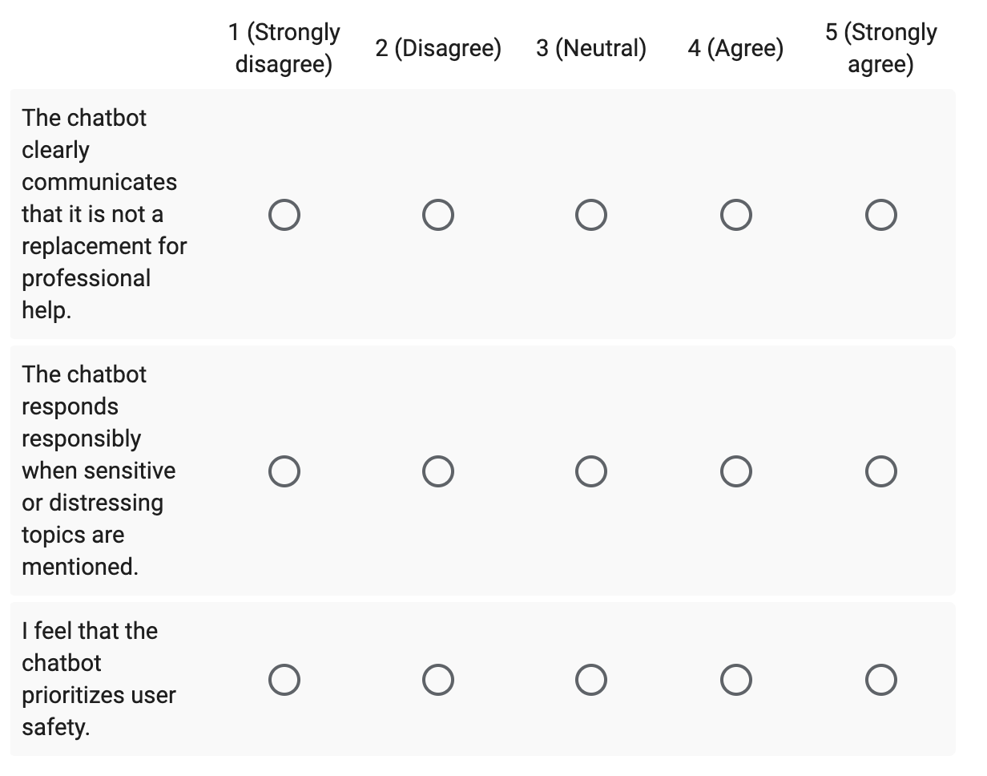
Figure 3.4.1 : Evaluation questions assessing ethical safety, responsible behavior, and user protection in the chatbot system.
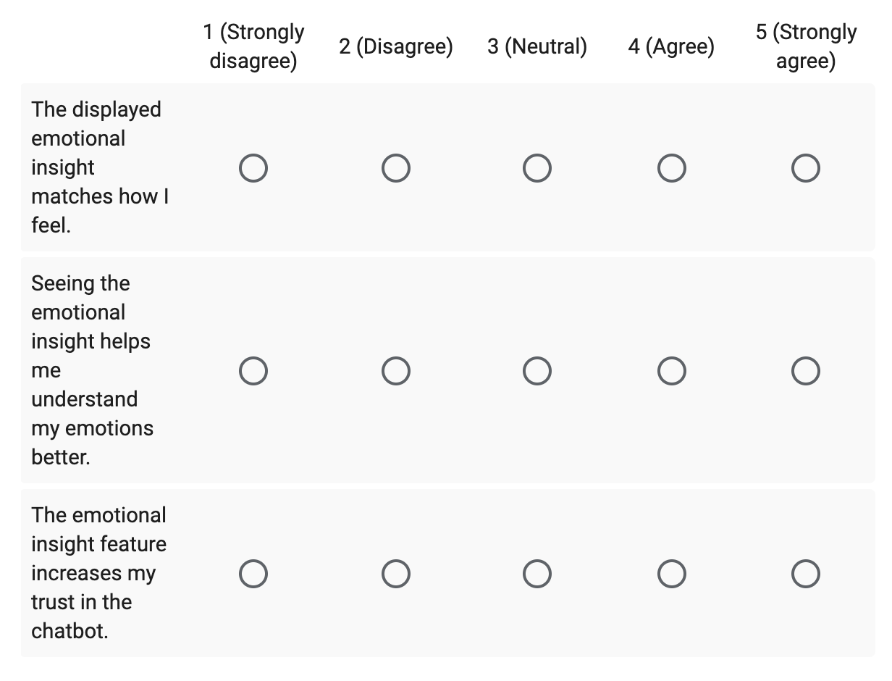
Figure 3.4.2 : Evaluation items measuring the accuracy and usefulness of the Emotional Insight feature for user self-awareness.
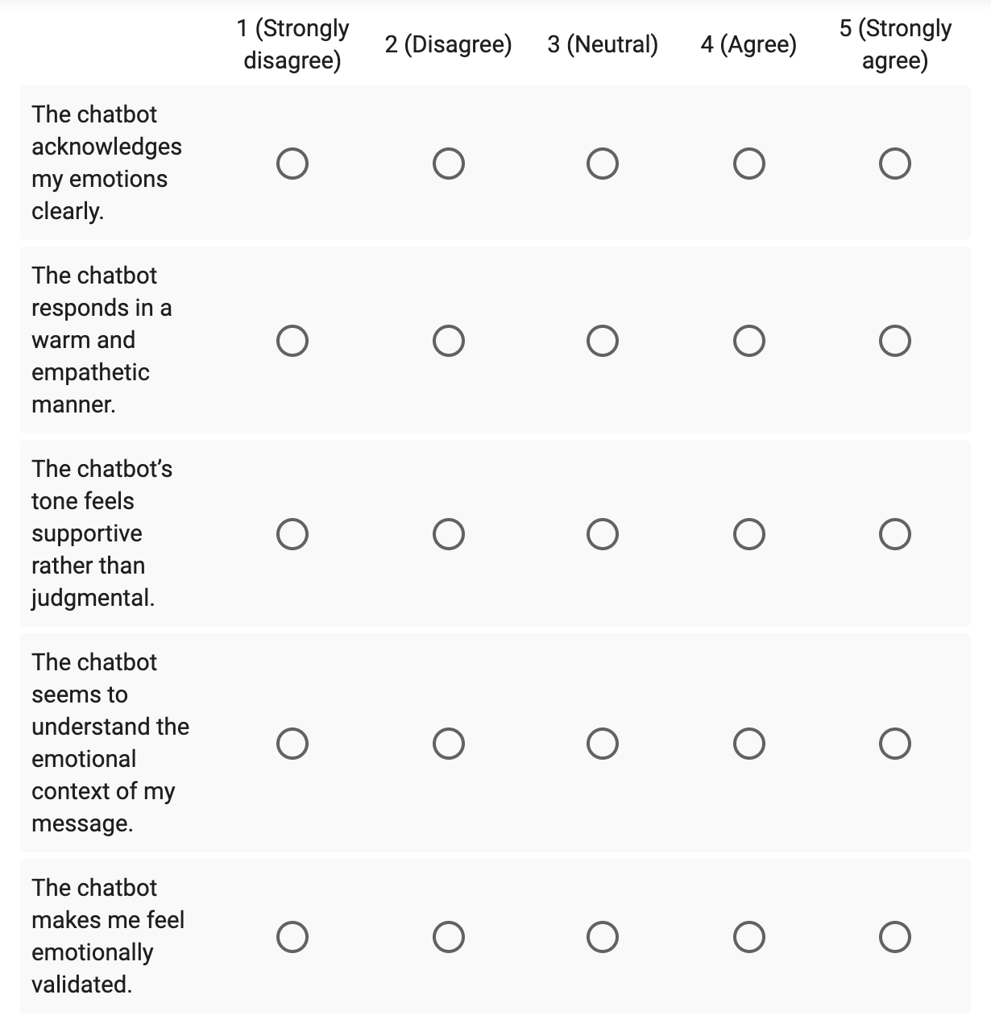
Figure 3.4.3 : Evaluation questions related to empathetic response quality, tone, and emotional validation.

3.5 Ethical Considerations
The system avoids medical claims or diagnosis. Crisis-related cues trigger safety messages recommending professional help. User privacy is respected, and no personal data is stored. The model is designed to avoid biased or culturally insensitive outputs.

3.6 Limitations
Limitations of this study include small sample size, dependency on model accuracy, limited handling of complex slang or mixed-language text, and the constraint that the system cannot replace professional mental health services.

CHAPTER 4
RESULTS AND DISCUSSION

4.1 Overview of Evaluation
This chapter presents the results and discussion derived from the development and evaluation of the empathetic mental health chatbot prototype. The evaluation emphasizes qualitative system behavior and user perception rather than predictive accuracy or clinical performance. This approach aligns with the project objective of developing a supportive, non-diagnostic conversational agent.

4.2 Qualitative Interaction Analysis
Figure 4.1 and Figure 4.2 present qualitative observations derived from representative user–chatbot interactions. These examples illustrate how the chatbot acknowledges user emotions, responds with empathetic language, and avoids judgmental or clinical phrasing.
Figure 4.1: Sample chatbot interaction demonstrating empathetic acknowledgment and supportive tone.
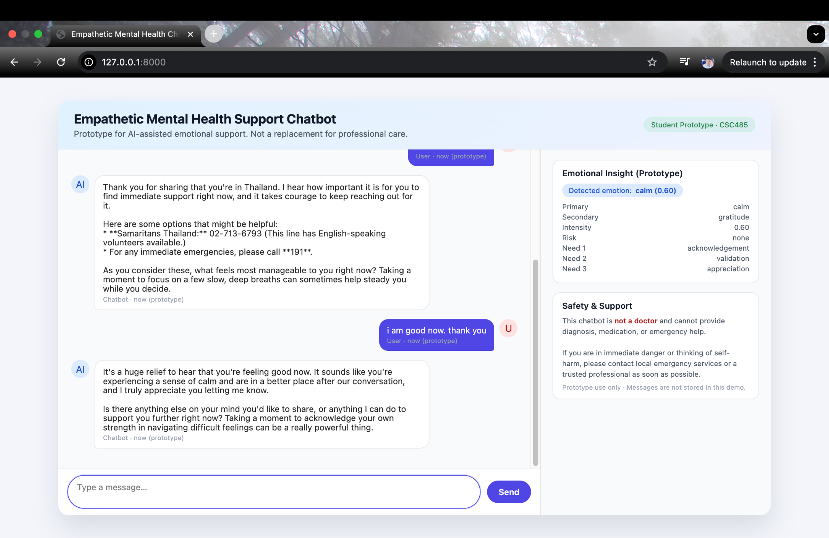
Figure 4.2: System processing flow for emotion detection, safety assessment, and response generation.

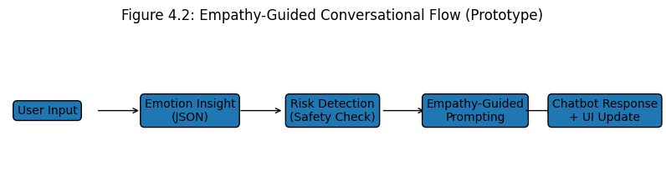4.3 User Feedback and Survey Results
User feedback was collected through a small-scale survey involving five participants. Participants interacted freely with the chatbot and evaluated their experience using a Likert-scale questionnaire.
Figure 4.3: Overall perception of emotional support and usefulness.
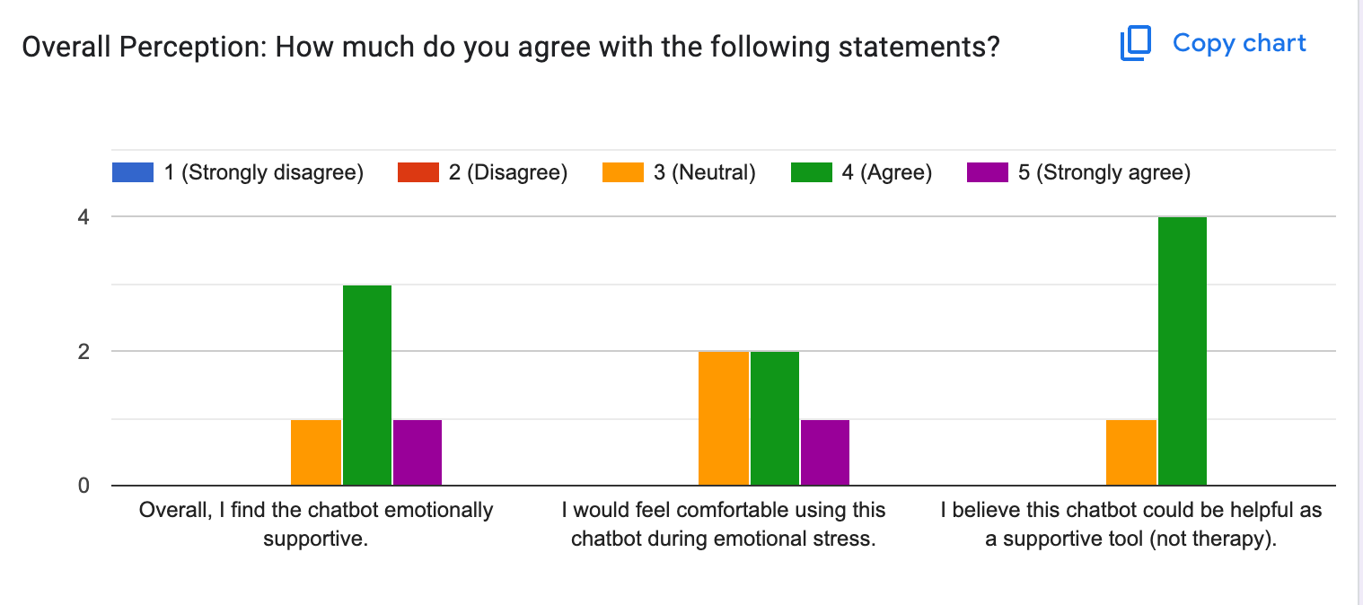
Figure 4.4: Safety and responsibility perception of the chatbot.
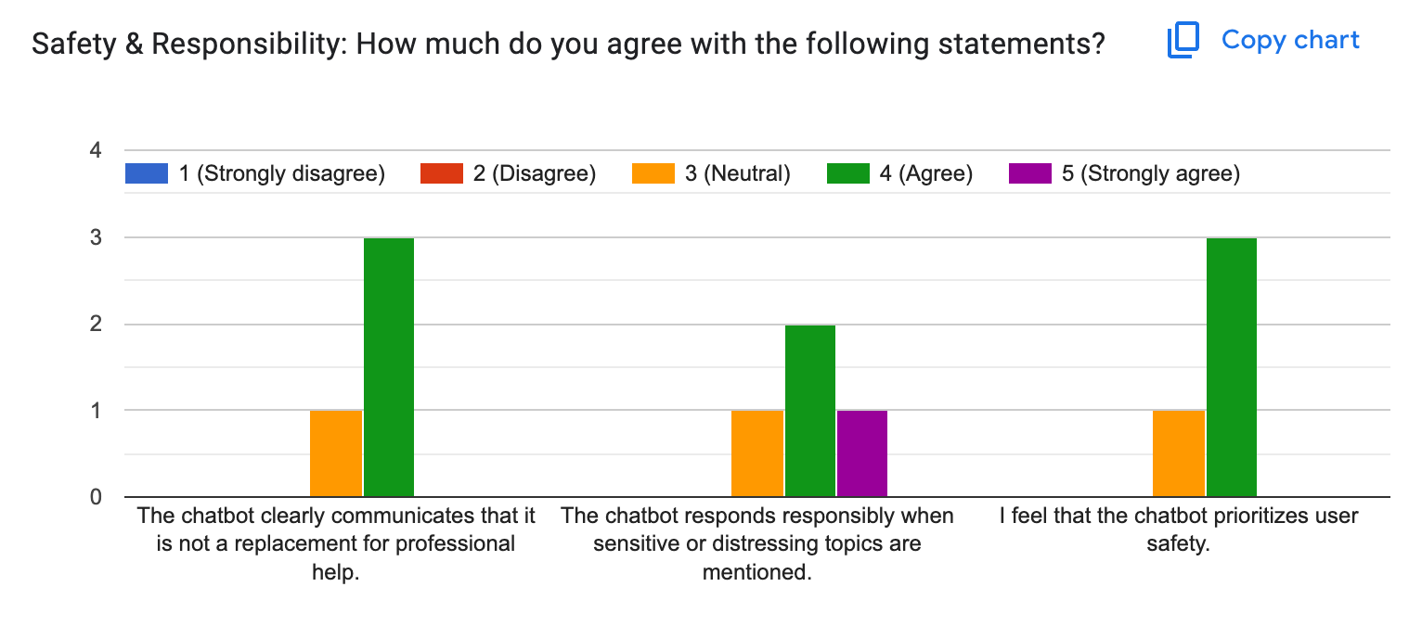
Figure 4.5: Emotional insight transparency and empathy perception.
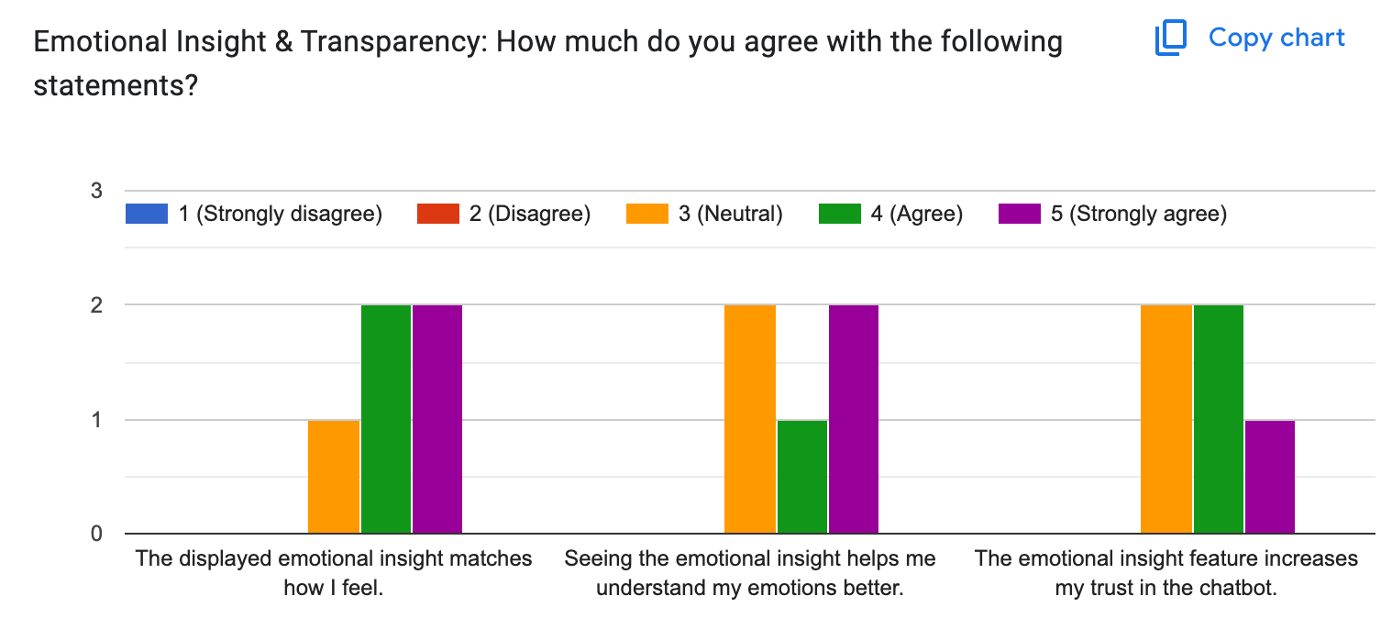

4.4 Discussion of Results
Survey results indicate that most participants perceived the chatbot as emotionally supportive and appropriate for non-clinical emotional assistance. Users reported that the chatbot clearly acknowledged emotions, maintained a warm tone, and respected ethical boundaries.
The emotional insight features increased user trust by making the system’s interpretation transparent. Additionally, safety mechanisms—such as disclaimers and crisis guidance—were perceived as responsible and reassuring.
These findings demonstrate that empathetic conversational behavior can be effectively achieved through prompt engineering, structured response logic, and interface design without requiring custom model training.

4.5 Limitations
Despite positive feedback, the evaluation has several limitations. The participant sample size was small, and results may not generalize to broader populations. Furthermore, emotional interpretation relies on a pre-trained language model, which may occasionally misinterpret user intent.

4.6 Chapter Summary
This chapter presented qualitative and user-centered evaluation results for the empathetic chatbot prototype. Overall, the system successfully demonstrated emotionally aware and ethically responsible conversational behavior within its intended scope.

CHAPTER 5
CONCLUSION

5.1 Conclusion
This study presented the design and implementation of an empathetic mental health chatbot prototype that integrates emotion awareness, empathetic response generation, and ethical safety constraints. The system demonstrates that pre-trained language models can be adapted to support emotionally sensitive interactions through careful prompt design and interface transparency.

5.2 Contributions of the Study
The primary contributions of this study include the development of an empathy-guided conversational architecture, the implementation of transparent emotional insight visualization, and the integration of safety-aware response mechanisms. The project also provides a practical example of responsible AI usage in mental health–adjacent contexts.

5.3 Limitations
This study is limited by its reliance on qualitative observation rather than large-scale user evaluation. The chatbot is not clinically validated and does not replace professional mental health services. Additionally, system performance is dependent on the underlying pre-trained language model.

5.4 Future Work
Future work may include formal user studies, multilingual emotion handling, personalization through emotional memory, and hybrid approaches combining symbolic emotion models with language-based generation.

References
Reuters (2024). AI fails to detect depression signs by Black Americans. https://www.reuters.com/business/healthcare-pharmaceuticals/ai-fails-detect-depression-signs-social-media-posts-by-black-americans-study-2024-03-28/
Lee et al. (2021). Artificial Intelligence for Mental Healthcare: Clinical Applications, Barriers, Facilitators, and Artificial Wisdom. https://pmc.ncbi.nlm.nih.gov/articles/PMC8349367
BMC Psychiatry (2025). The application of artificial intelligence in the field of mental health: a systematic review. https://bmcpsychiatry.biomedcentral.com/articles/10.1186/s12888-025-06483-2
Psychological Medicine Review (Cambridge). AI in mental health care: a systematic review of diagnosis, monitoring and intervention applications. https://www.cambridge.org/core/journals/psychological-medicine/article/artificial-intelligence-in-mental-health-care-a-systematic-review-of-diagnosis-monitoring-and-intervention-applications/04DBD2D05976C9B1873B475018695418
arXiv (2024). https://arxiv.org/abs/2406.11852
arXiv (2025). https://arxiv.org/abs/2502.00451
Fitzpatrick, K. K., Darcy, A., & Vierhile, M. (2017). Delivering cognitive behavior therapy to young adults with symptoms of depression and anxiety using a fully automated conversational agent.
https://www.ncbi.nlm.nih.gov/pmc/articles/PMC5489042/
Rogers, C. R. (1957). The necessary and sufficient conditions of therapeutic personality change.
https://doi.org/10.1037/h0045357
Gross, J. J. (2015). Emotion regulation: Current status and future prospects.
https://doi.org/10.1177/1754073914562819
Lieberman, M. D., et al. (2007). Putting feelings into words: Affect labeling disrupts amygdala activity.
https://www.ncbi.nlm.nih.gov/pmc/articles/PMC1978403/

